***PLSQL_EXERCISES***

***Exercise 1: Control Structures***

* *Table Creation and Data Insert*

*BEGIN*

*EXECUTE IMMEDIATE 'DROP TABLE loans';*

*EXECUTE IMMEDIATE 'DROP TABLE customers';*

*EXCEPTION*

*WHEN OTHERS THEN NULL;*

*END;*

*/*

*CREATE TABLE customers (*

*customer_id NUMBER PRIMARY KEY,*

*customer_name VARCHAR2(100),*

*age NUMBER,*

*balance NUMBER(10,2),*

*is_vip VARCHAR2(5) DEFAULT 'FALSE'*

*);*

*CREATE TABLE loans (*

*loan_id NUMBER PRIMARY KEY,*

*customer_id NUMBER,*

*loan_amount NUMBER(10,2),*

*interest_rate NUMBER(5,2),*

*due_date DATE,*

*FOREIGN KEY (customer_id) REFERENCES customers(customer_id)*

*);*

*INSERT INTO customers VALUES (1, 'John Smith', 65, 15000.00, 'FALSE');*

*INSERT INTO customers VALUES (2, 'Mary Johnson', 45, 8500.00, 'FALSE');*

*INSERT INTO customers VALUES (3, 'Robert Brown', 72, 25000.00, 'FALSE');*

*INSERT INTO customers VALUES (4, 'Sarah Davis', 55, 12000.00, 'FALSE');*

*INSERT INTO customers VALUES (5, 'Michael Wilson', 68, 7500.00, 'FALSE');*

*INSERT INTO loans VALUES (1, 1, 50000.00, 5.5, DATE '2025-07-15');*

*INSERT INTO loans VALUES (2, 2, 30000.00, 6.0, DATE '2025-07-20');*

*INSERT INTO loans VALUES (3, 3, 75000.00, 5.0, DATE '2025-08-10');*

*INSERT INTO loans VALUES (4, 4, 40000.00, 5.8, DATE '2025-07-25');*

*INSERT INTO loans VALUES (5, 5, 20000.00, 6.2, DATE '2025-07-05');*

*COMMIT;*

* ***PL/SQL Code for All Scenarios***

*Scenario 1: Interest Discount*

*BEGIN*

*DBMS_OUTPUT.PUT_LINE('=== Interest Rate Discount for Customers Above 60 ===');*

*FOR rec IN (*

*SELECT c.customer_id, c.customer_name, c.age, l.loan_id, l.interest_rate*

*FROM customers c*

*JOIN loans l ON c.customer_id = l.customer_id*

*WHERE c.age > 60*

*) LOOP*

*UPDATE loans*

*SET interest_rate = interest_rate - 1*

*WHERE loan_id = rec.loan_id;*

*DBMS_OUTPUT.PUT_LINE('Customer: ' || rec.customer_name ||*

*', Loan ID: ' || rec.loan_id ||*

*', New Rate: ' || (rec.interest_rate - 1));*

*END LOOP;*

*COMMIT;*

*END;*

*/*

*Scenario 2: Promote VIP*

*BEGIN*

*DBMS_OUTPUT.PUT_LINE(CHR(10) || '=== Promoting Customers to VIP (Balance > $10,000) ===');*

*FOR rec IN (SELECT customer_id, customer_name, balance FROM customers WHERE balance > 10000) LOOP*

*UPDATE customers SET is_vip = 'TRUE' WHERE customer_id = rec.customer_id;*

*DBMS_OUTPUT.PUT_LINE('Customer: ' || rec.customer_name ||*

*' promoted to VIP (Balance: $' || TO_CHAR(rec.balance, '999,999.00') || ')');*

*END LOOP;*

*COMMIT;*

*END;*

*/*

*Scenario 3: Payment Reminders*

*BEGIN*

*DBMS_OUTPUT.PUT_LINE(CHR(10) || '=== Loan Payment Reminders (Due within 30 days) ===');*

*DBMS_OUTPUT.PUT_LINE('Current Date: ' || TO_CHAR(SYSDATE, 'DD-MON-YYYY'));*

*FOR rec IN (*

*SELECT l.loan_id, c.customer_name, l.loan_amount, l.due_date,*

*(l.due_date - SYSDATE) AS days_until_due*

*FROM loans l JOIN customers c ON l.customer_id = c.customer_id*

*WHERE l.due_date BETWEEN SYSDATE AND SYSDATE + 30*

*ORDER BY l.due_date*

*) LOOP*

*DBMS_OUTPUT.PUT_LINE(CHR(10) || 'REMINDER: Dear ' || rec.customer_name || ',');*

*DBMS_OUTPUT.PUT_LINE('Your loan of $' || TO_CHAR(rec.loan_amount, '999,999.00') ||*

*' is due on ' || TO_CHAR(rec.due_date, 'DD-MON-YYYY') ||*

*' (' || ROUND(rec.days_until_due) || ' days remaining)');*

*IF ROUND(rec.days_until_due) <= 7 THEN*

*DBMS_OUTPUT.PUT_LINE('*** URGENT - Due within a week! ***');*

*END IF;*

*END LOOP;*

*END;*

*/*

***OUTPUT:***

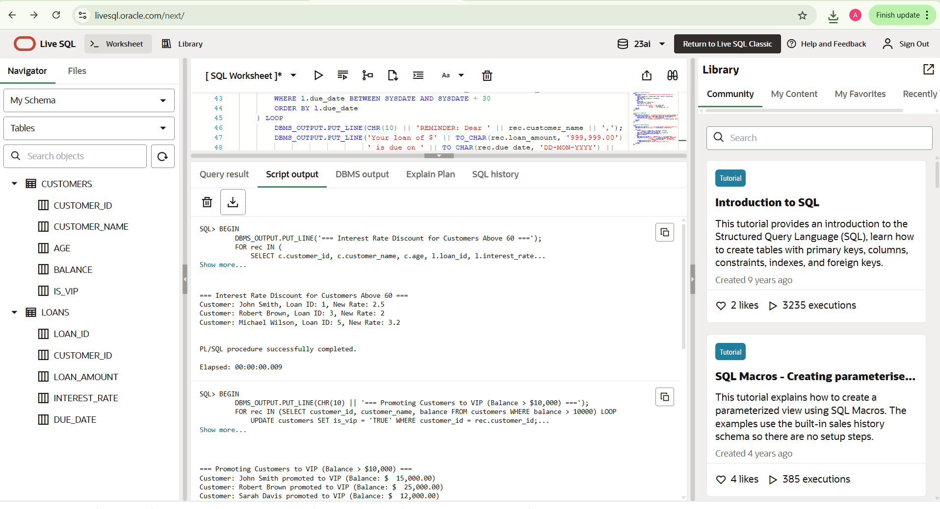

***Exercise 3: Stored Procedures***

* *Table Creation and Data Insert*

*CREATE TABLE accounts (*

*account_id NUMBER PRIMARY KEY,*

*customer_name VARCHAR2(100),*

*account_type VARCHAR2(20),*

*balance NUMBER(10,2)*

*);*

*CREATE TABLE employees (*

*emp_id NUMBER PRIMARY KEY,*

*emp_name VARCHAR2(100),*

*department VARCHAR2(50),*

*salary NUMBER(10,2)*

*);*

*INSERT INTO accounts VALUES (1, 'John Smith', 'Savings', 10000);*

*INSERT INTO accounts VALUES (2, 'Mary Johnson', 'Savings', 12000);*

*INSERT INTO accounts VALUES (3, 'Robert Brown', 'Current', 8000);*

*INSERT INTO accounts VALUES (4, 'Sarah Davis', 'Savings', 15000);*

*INSERT INTO employees VALUES (101, 'Alice', 'Sales', 50000);*

*INSERT INTO employees VALUES (102, 'Bob', 'Sales', 55000);*

*INSERT INTO employees VALUES (103, 'Charlie', 'HR', 48000);*

*COMMIT;*

* ***PL/SQL Code for All Scenarios***

*CREATE OR REPLACE PROCEDURE ProcessMonthlyInterest AS*

*BEGIN*

*DBMS_OUTPUT.PUT_LINE('=== Monthly Interest Process ===');*

*FOR acc IN (SELECT account_id, balance FROM accounts WHERE account_type = 'Savings') LOOP*

*UPDATE accounts*

*SET balance = balance + (balance * 0.01)*

*WHERE account_id = acc.account_id;*

*DBMS_OUTPUT.PUT_LINE('Interest added to Account ID: ' || acc.account_id);*

*END LOOP;*

*COMMIT;*

*END;*

*/*

*CREATE OR REPLACE PROCEDURE UpdateEmployeeBonus (*

*dept_name IN VARCHAR2,*

*bonus_percent IN NUMBER*

*) AS*

*BEGIN*

*DBMS_OUTPUT.PUT_LINE('=== Employee Bonus Update ===');*

*FOR emp IN (SELECT emp_id FROM employees WHERE department = dept_name) LOOP*

*UPDATE employees*

*SET salary = salary + (salary * bonus_percent / 100)*

*WHERE emp_id = emp.emp_id;*

*DBMS_OUTPUT.PUT_LINE('Bonus applied to Employee ID: ' || emp.emp_id);*

*END LOOP;*

*COMMIT;*

*END;*

*/*

*CREATE OR REPLACE PROCEDURE TransferFunds (*

*from_acc_id IN NUMBER,*

*to_acc_id IN NUMBER,*

*amount IN NUMBER*

*) AS*

*from_balance NUMBER;*

*BEGIN*

*SELECT balance INTO from_balance FROM accounts WHERE account_id = from_acc_id;*

*IF from_balance < amount THEN*

*RAISE_APPLICATION_ERROR(-20001, 'Insufficient balance in source account');*

*ELSE*

*UPDATE accounts SET balance = balance - amount WHERE account_id = from_acc_id;*

*UPDATE accounts SET balance = balance + amount WHERE account_id = to_acc_id;*

*DBMS_OUTPUT.PUT_LINE('Transferred ₹' || amount || ' from A/c ' || from_acc_id || ' to A/c ' || to_acc_id);*

*END IF;*

*COMMIT;*

*END;*

*/*

*BEGIN*

*DBMS_OUTPUT.PUT_LINE('=== RUNNING ALL 3 SCENARIOS ===');*

*ProcessMonthlyInterest;*

*UpdateEmployeeBonus('Sales', 10);*

*TransferFunds(1, 3, 2000);*

*DBMS_OUTPUT.PUT_LINE('=== ALL SCENARIOS COMPLETED ===');*

*END;*

*/*

***OUTPUT:***



